Megan Leonard

5/30/2021

COMP 201 Homework 2

Answer the following questions based on your reading of the textbook, the module study notes, the videos, and the instructor’s presentation this week.

1. Representations of data
2. (Englander, Exercise 4.2, page 132) what is the ASCII representation for the numeral −3.1415 in binary? In octal? In hexadecimal? In decimal?

Binary: 0010110100110011001011100011000100110100001100010011010

HexaDecimal: 2D332E31343135

Octal: 055063056061064061065

Decimal: 045051046049052049053

1. What is the EBCDIC representation for the numeral +1,250.1? (Include the comma.)

EBCDIC: 4EF16BF2F5F04BF1

1. (Englander, exercise 4.3, page 132) What character string does the binary ASCII code

1010100 1101000 1101001 1110011 0100000 1101001 1110011

0100000 1000101 1000001 1010011 1011001 0100001

Answer: This is EASY!

1. (Englander, exercise 4.5) As an alternative alphanumeric code, consider a code where punched holes in the columns of a card represent alphanumeric codes. The punched hole represents a "1"; all other bits are "0". The Hollerith code shown in [**Figure E4.2**](javascript:moveTo('e4.2');) is an example of such a code. This code has been used to represent a message on the card in [**Figure E4.3**](javascript:moveTo('e4.3');)**.** Each row represents a code level from 0 to 12. Levels 12 and 11, which are not labeled on the card, are the top row and next-to-top rows, respectively. Each column represents a single character, so the card can hold one eighty-column line of text. (This card, prevalent in the 1960s and 1970s as a means of data input, is the reason that text-based displays are still limited to eighty characters per line.) Translate the card in [**Figure E4.3**](javascript:moveTo('e4.3');)**.**

MICKEY MOUSE *LOVES* MINNIE, 5000 KISSES

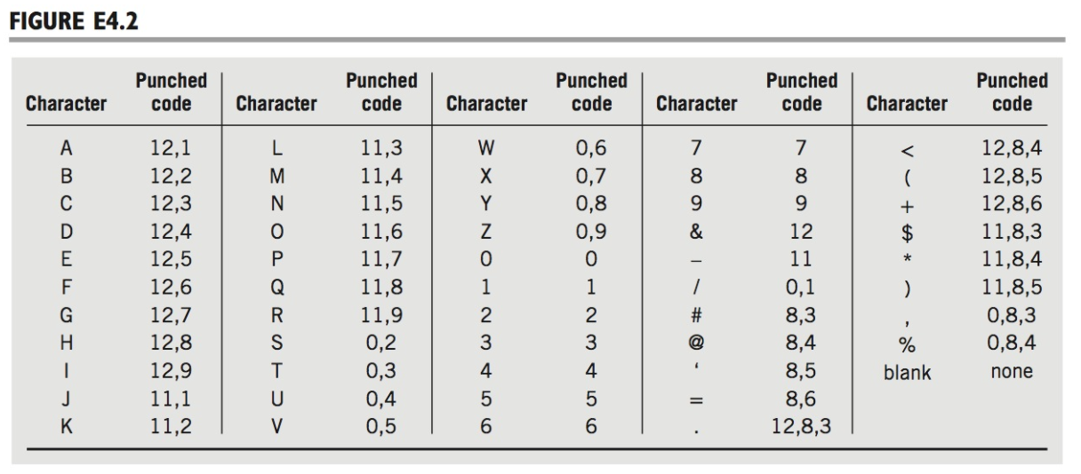

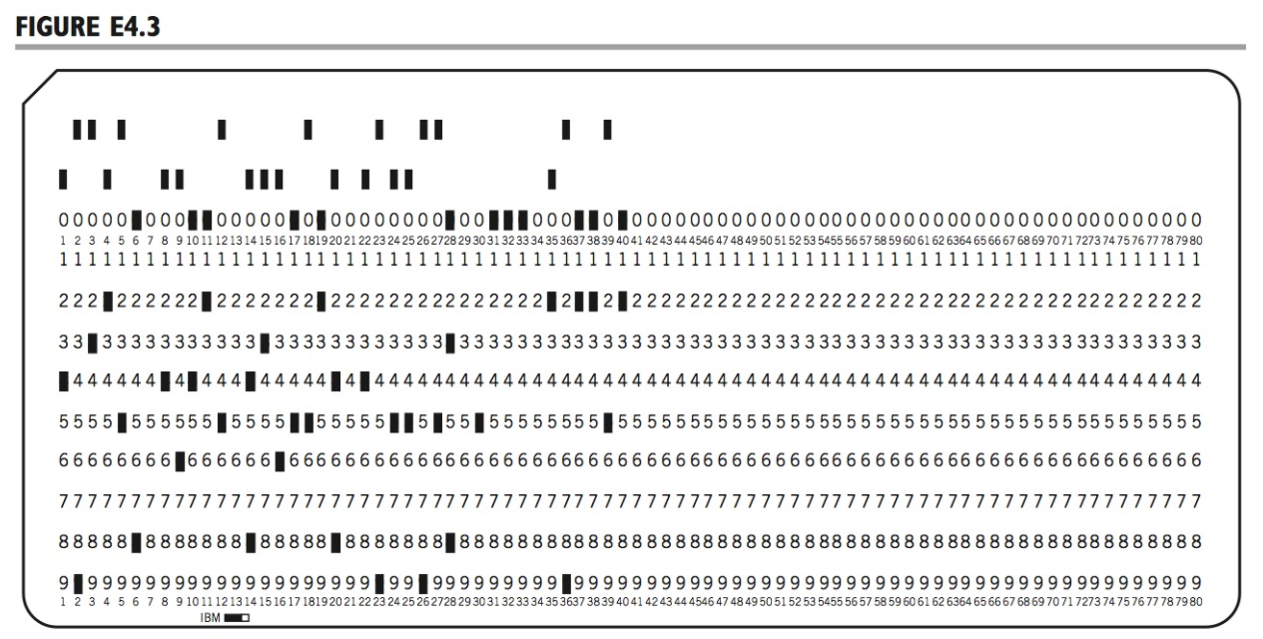

1. (Englander, exercise 4.7) Write a program in your favorite language that will convert all ASCII uppercase and lowercase letters to EBCDIC code. For an additional challenge, also convert the punctuation symbols, indicating with a failure-to-convert message, those symbols that are not represented in the EBCDIC system.

Use a lookup table for the conversions.

1. (Englander, exercise 5.9) Add the following two 12-bit binary 2's complement numbers. Then convert each number to decimal and check the results.

http://0-proquest.safaribooksonline.com.olinkserver.franklin.edu/getfile?item=NTdnMWEvcmY3ZG0wdDgvaS9lZ3M5NHAyaTQxYzk3cHVzLjU5ZzNuMC8-

1010100101000 translated to 1645+3771=5416 which is the decimal of the given binary.

http://0-proquest.safaribooksonline.com.olinkserver.franklin.edu/getfile?item=NTdnMWEvcmY3ZG0wdDgvaS9lZ3M5NHAyaTQxYzk3cHVzLjUwZzRuMC8-

01101011001000 translated to 2764+4092 = 6856 which is the decimal of the given binary.

1. (Englander, exercise 5.10) Given the positive number 2468, what is the largest positive digit that you can add that will not cause overflow in a four-digit decimal, 10's complement number system?

Using 10’s complement number we can shift the number over so we have 9999- 2468 = 7531 which is the largest that can be added without overflow.

1. (Englander, exercise 5.11) In 12's complement base 12, how would you know if a number is positive or negative?

Being that 12 is an even number it can be split as the first half is positive while the second half is negative. This would mean that 0-5 is positive while 6-12 is negative.

1. (Englander, exercise 5.17)
   1. Convert the number 123.57 × 1015 to the format SEEM M M M, with the exponent stored excess-49. The implied decimal point is to the right of the first mantissa digit.
   2. What is the smallest number you can use with this format before underflow occurs?
2. 012357
3. The smallest number that can be used before underflow is 1x10^67
4. In two to three paragraphs of prose (i.e. sentences, not bullet lists, and 350+ words) using APA style citations if needed, summarize, and interact with the content that was covered this week in class. In your summary, you should highlight the major topics, theories, practices, and knowledge that were covered. Your summary should also interact with the material through personal observations, reflections, and applications to the field of study. In particular, highlight what surprised, enlightened, or otherwise engaged you. Make sure to include at least one thing that you’re still confused about. In other words, you should think and write critically not just about what was presented but also what you have learned through the session. Feel free to ask questions in this as well since it will be returned to you with answers.

This week we investigated overflow, underflow, ASCII, and EBCDIC. The conversions between the different bases are not too hard thanks to the figures and tables given to us in the book. The work is not too hard and is more time consuming than difficult. Hollerith’s code took me a moment to figure out as I was making it more difficult than it was. I was confused with the first couple of letters but after deciphering the full code it made more sense. Will we be working with more code translations in this class or is that for a different class? Overall this week was interesting to learn about.